## Import Vod - mismatch duration && Match CCUR

**Import Vod - mismatch duration**

Possivelmente ocorreu um erro a converter o VOD CIPK7B0EA1750DE44FF7.  
wtfarm10 $ ffprobe

**Match CCUR**

Carrie CIPK7B0EA1750DE44FF7 OK NOK OK 000872_ZAP_031851_LUS_CARRIE2013_66428000

ZAP_IRIS_BO/Reporting/CCUR_MATCH : AssetMap.csv vs Lista.txt

Verificar qual a versão em storage e alterar no Mongo da IRIS SRM_AssetMappings .

Informar a NOS.

[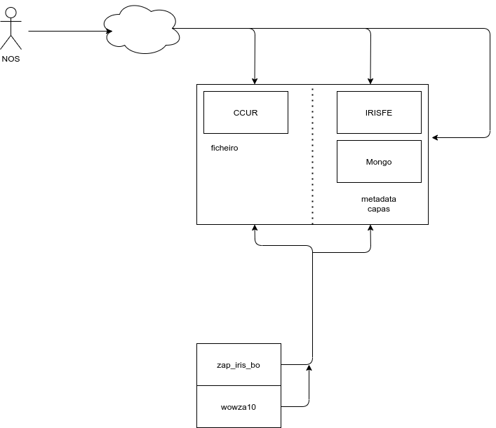](https://gitlab.zap.intra/integracao/kb/uploads/ae5a22dae56f92e87ef3f182b35e18a8/image.png)